**Assignment 1**

**"""Task 1: Perform Basic Mathematical Operations**

**Problem Statement: Write a Python program that does the following:**

**1. Takes two numbers as input from the user.**

**2. Performs the basic mathematical operations on these two numbers:**

**o Addition**

**o Subtraction**

**o Multiplication**

**o Division**

**3. Displays the results of each operation on the screen.**

**"""**

a=int(input("Enter First number:"))

b=int(input("Enter second number:"))

c=a+b

print("The Addition is=",c)

c=a-b

print("The Subtraction is=",c)

c=a*b

print("The Multiplication is=",c)

c=a/b

print("The Division is=",c)

**Output**

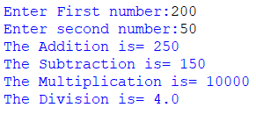

**Task 2: Create a Personalized Greeting**

**Problem Statement:** Write a Python program that:

1.  Takes a user's first name and last name as input.

2.  Concatenates the first name and last name into a full name.

3.  Prints a personalized greeting message using the full name.

str1=input("Enter your First Name:")

str2=input("Enter second Name:")

str=str1+str2

print("Hello",str,"Welcome to Python")

Output

